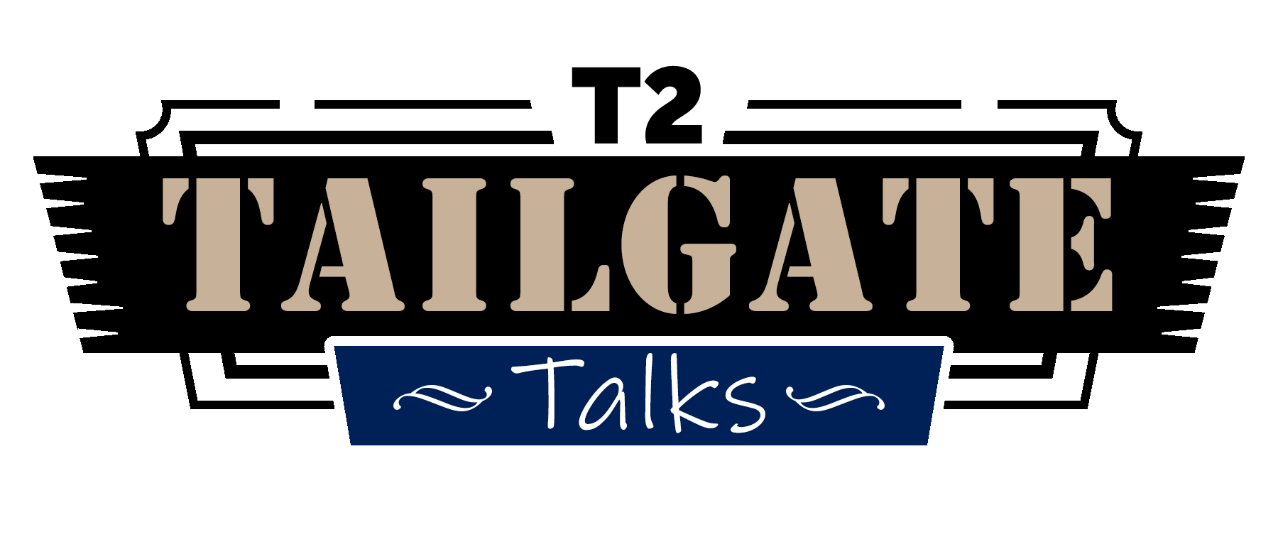

Safety Brief Series

Safety Brief - 2015 - 1

HOW TO CONDUCT A TAILGATE TALK
Use Tailgate Talks as a guide to help you conduct 10-15 minute tailgate training sessions for your crew.
Key Points:
- Choose one safety topic per session.
- Be concise. Keep it short.
- Keep the sessions small.
- Meet in a place that’s comfortable for workers.
- Allow time for questions and answers.
- Document the training.

The Concept
Tailgate training is a gathering of a small group of workers around the tailgate of a truck or other spot for a brief training session on a single safety topic.

Plan Logistics
- Limit sessions to a small number of workers. Six to 10 is a good number.
- Choose a quiet spot that is comfortable for your workers.
- Hold sessions early in the week, but not on Monday mornings.
- Conduct tailgate training sessions an average of once a week. Dedicate specific time for the
training.

Choose Safety Topics
- Review your accident records. Pick topics related to accidents that have occurred.
- Walk around your operation. Look for situations that could result in injuries.
- Ask employees for their ideas.
- Read newsletters and other articles for more information. Use them for additional ideas.

Prepare Your Presentation
- Use a one-page fact sheet like the Tailgate Talks provided by the T2 Center (find them using this
link: www.t2center.uconn.edu) or outline your own ideas.
- Look for visual aids. Examples: warning signs, a flipchart, an illustration on poster board.
- Photocopy handouts ahead of time.
- Read through the materials the night before.

Conduct the Session
- Keep your presentation informal.
- Don’t use words your employees won’t understand.
- Use visual aids.
- Involve your workers in discussion of the topic.
- Allow time for questions at the end.
- Have workers sign a sheet showing they were trained and keep it on file.

Tailgate Training Do’s and Don’ts
DO:  - Limit sessions to no more than 15 minutes.  - Choose topics that relate to your operation.  - Hold sessions an average of once a week. | DON’T:  - Conduct training sessions on Monday mornings.  - Speak in a manner workers won’t understand.  - Discourage employees from asking  questions.

Informal
- Sessions held on employees’ turf.
- No “lecturing.”
- Trainer speaks employees’ language.
- Employees are comfortable and more willing to participate.

Very Focused
- One safety topic presented at a time.
- Easier for most workers to digest one topic at a time.
- Puts safety information on the “front line” where it’s most effective.

Brief Sessions
- Sessions run no more than 15 minutes.
- Doesn’t lose employees’ attention.
- Employees more likely to look forward to shorter sessions.

Repetition
- Consistently held sessions reinforce the importance of safety.
- Employees are more likely to remember what they heard.
- Employees are more likely to put concepts into action.
- Constant reinforcement keeps ideas fresh.

Employee Involvement
- Workers raise issues management was unaware of.
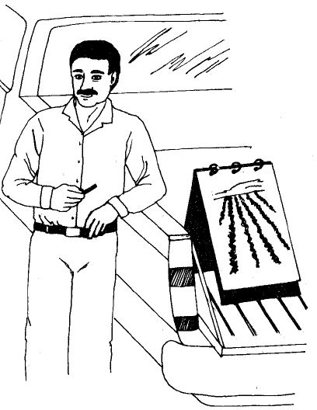
- Employees see their ideas put into action.
- Enhances two-way communication between workers and supervisors.
- Improves worker morale. Employees become part of the safety team.

Line Supervisor Involvement
- Gets line supervisors involved in the safety program.
- Supervisors who train are more likely to “buy into” safety.
- Increases line supervisors’ self-confidence.

Basic Training Tips:
- Be enthusiastic about the topic.
- Don’t speak in a monotone voice.
- Don’t “spoon-feed” information to trainees. Get them involved.
- Choose topics employees can relate to.
- Set a good example.
- Reward good ideas and safe practices.
- Show you really care.

For more Tailgate Talks, Safety Briefs or more information about the Kentucky Technology Transfer Center, visit us at: www.kyt2.com
